**DETAIL DESIGN**



**Author: IMAGINEERS**

**Date: 19/03/2017**

**Revision history**

|  |  |  |  |
| --- | --- | --- | --- |
| **Version** | **Date** | **Author** | **Notes** |
| **1.0** | 19/03/2017 | Phuong Nguyen | Created |
|  |  |  |  |
|  |  |  |  |
|  |  |  |  |

Contents

I. INTRODUCTION 4

II. PROTOTYPE 4

1. SWAPPAL_VIEW MYPAGE 4

2 SWAPPAL_CREATE PROFILE 4

2 SWAPPAL_EDIT MY PAGE 5

3 SWAPPAL_VIEW ABOUT ME 6

4 SWAPPAL_EDIT ABOUT ME 7

5 SWAPPAL_REVIEW PAGE 9

6 SWAPPAL_SEARCH SKILLS 9

# INTRODUCTION

This document is created to show the design GUI or sketches of the Swappal website. This document is create for

* Scrum Team
* Product Owner

# PROTOTYPE

## SWAPPAL_VIEW MYPAGE

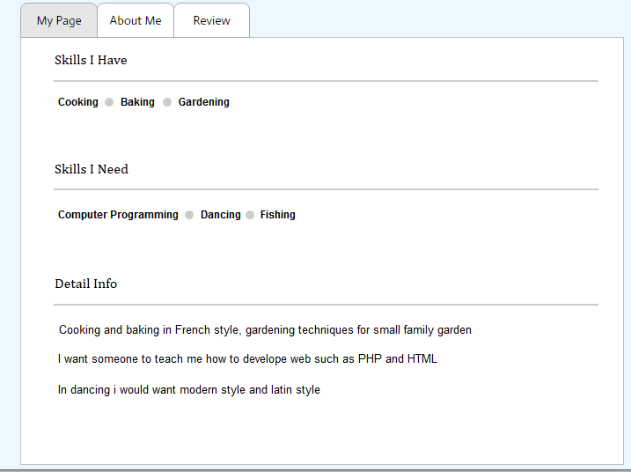

## SWAPPAL_CREATE PROFILE

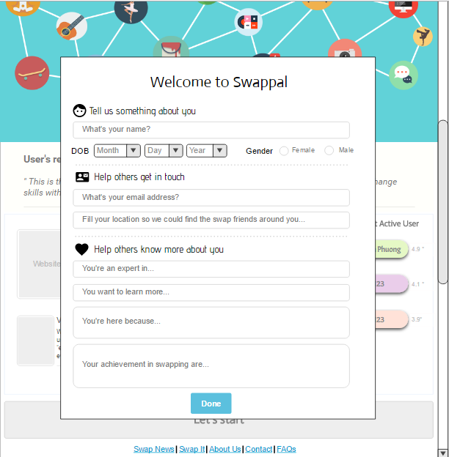

## SWAPPAL_EDIT MY PAGE

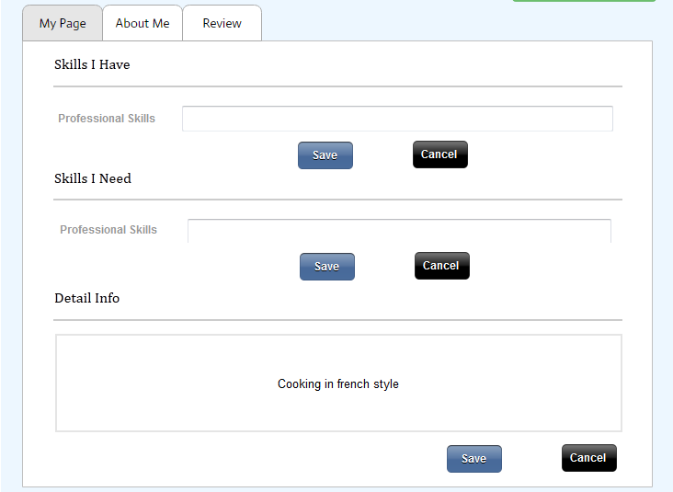

## SWAPPAL_VIEW ABOUT ME

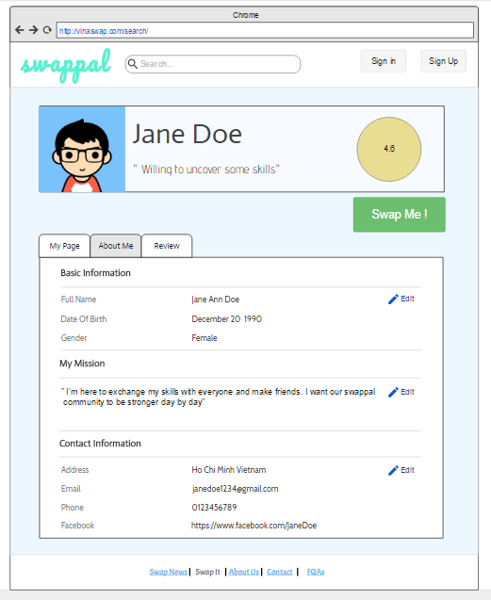

## SWAPPAL_EDIT ABOUT ME

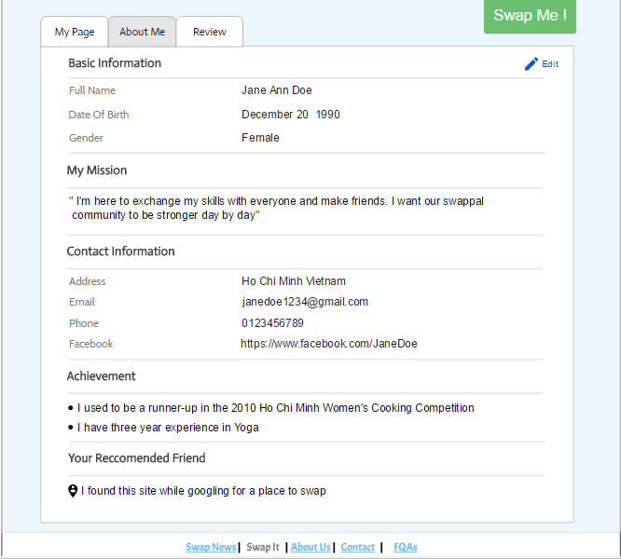

## SWAPPAL_REVIEW PAGE

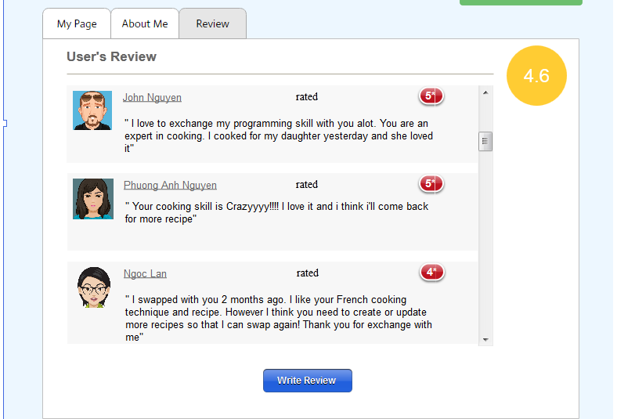

## SWAPPAL_SEARCH SKILLS

